

**School of Mechanical & Manufacturing Engineering (SMME), National University of Science and Technology (NUST),**

**Sector H-12, Islamabad**

**Fundamentals of programming assignment**

**Name: Muahddasa Sohail**

**Class: AE-01 (SMME)**

**CMS:455387**

**Course code: CS-114**

**Fundamentals of Programming Assignment**

1. Write a C++ program, take two strings as input from user and check if both strings are equal or not. If they are equal make them unequal by rotating string. e.g., Hello is turned into olleH etc.

**Program**:

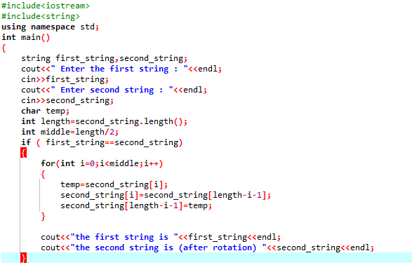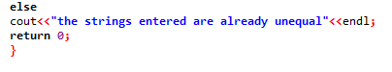

Figure program of q1

**Output:**

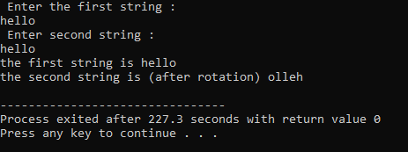

Figure output of q2

1. Write a C++program for a string which may contain lowercase and uppercase characters. The task is to remove all duplicate characters from the string and find the resultant string.

**Program:**

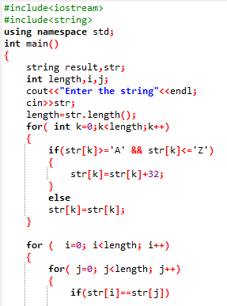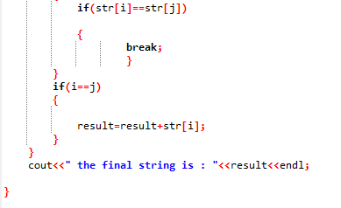

Figure program of q2

**Output:**

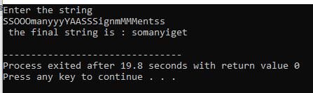

Figure output of q2

1. Suppose an integer array a[5] = {1,2,3,4,5}. Add more elements to it and display them in C++.

**Program**:

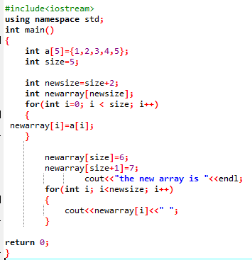

Figure program of q3

**Output**:



Figure outout of q3

1. Write a C++ program that uses a while loop to find the largest prime number less than a given positive integer N. Your program should take the value of N as input from the user and then find the largest prime number less than or equal to N. You are not allowed to use any library or pre-existing functions to check for prime numbers.

**Program:**

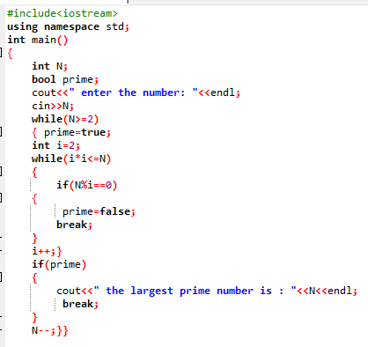

Figure program of q4

**Output**:

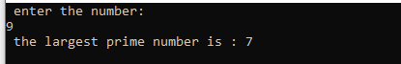

Figure output of q4

1. Implement Bubble Sort on an array of 6 integers.

**Program**:

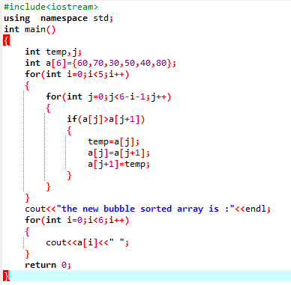

Figure program of q5

**Output**:



Figure output of q5

1. Solve any Aerospace/Real Life Problem using C++ Programming.

**Real life aerospace problem:**

Conserving fuel is important for two very obvious reasons. First, given the high price of oil, airlines can save considerable sums of money by using less fuel through improved fuel efficiency. Secondly, if an airplane uses less fuel, it will produce lower CO2 emissions.

Therefore, it is necessary to calculate the fuel efficiency of an airplane

Fuel efficiency is the amount of energy imparted to the plane per unit of energy in the fuel.

**Calculating the fuel efficiency of an aircraft.**

* We define an Aircraft struct to store the input data, including the fuel consumption in litres per kilometre and the distance travelled in kilometres.
* The calculateFuelEfficiency() function takes an Aircraft object as input and calculates the fuel efficiency in kilometres per litre. It does this by taking the reciprocal of the fuel consumption.
* In the main() function, we prompt the user to enter the fuel consumption and distance travelle. We then call the calculateFuelEfficiency() function, passing the Aircraft object, and store the result in the fuelEfficiency variable. Finally, we display the calculated fuel efficiency to the user.

**Program**:

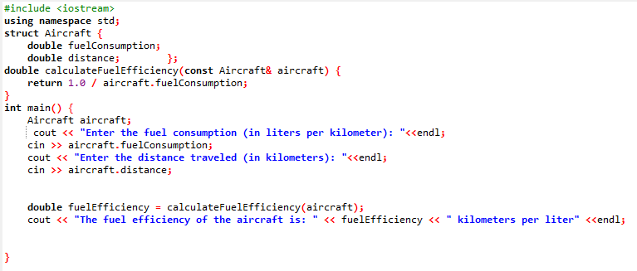

Figure calculating the fuel efficiency of an airplane

**Output:**

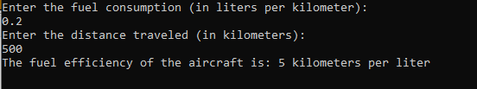

**Conclusion:**

This means that the aircraft is able to travel 5 kilometres for every litre of fuel consumed, given the provided fuel consumption rate and distance travelled.

